Set 14
1. Grouped Bar Chart
Aim
To create a grouped bar chart in R to visualize the sales of each product during the first quarter.
Code:
library(ggplot2)
data <- data.frame(
Product = c("Product A", "Product B", "Product C"),
January = c(2000, 1500, 1200),
February = c(2200, 1800, 1400),
March = c(2400, 1600, 1100)
)
# Convert data into long format
sales <- data.frame(
Product = rep(data$Product, 3),
Month = rep(c("January", "February", "March"), each = 3),
Sales = c(data$January, data$February, data$March)
)
# Grouped bar chart
ggplot(sales, aes(x = Product, y = Sales, fill = Month)) +
geom_bar(stat = "identity", position = "dodge") +
labs(
title = "Product Sales - First Quarter",
x = "Product",
y = "Sales",
fill = "Month"
) +
theme_minimal()
Output:
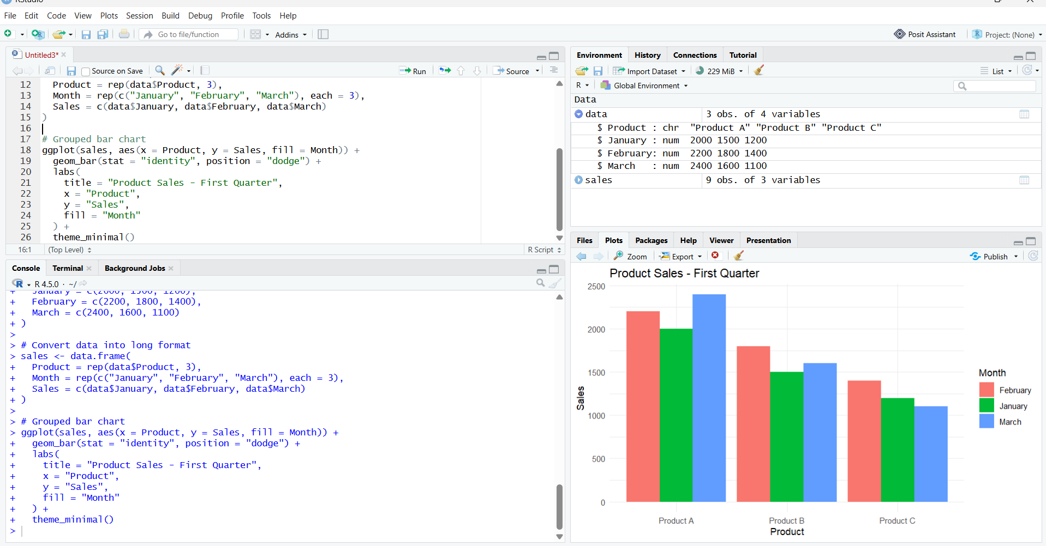
2. Stacked Area Chart
Aim
To create a stacked area chart in R to represent the overall sales trend of all products over three months.
Code:
library(ggplot2)
sales <- data.frame(
Month = rep(c("January", "February", "March"), each = 3),
Product = rep(c("Product A", "Product B", "Product C"), 3),
Sales = c(
2000, 1500, 1200,
2200, 1800, 1400,
2400, 1600, 1100
)
)
ggplot(sales, aes(x = Month, y = Sales, fill = Product, group = Product)) +
geom_area() +
labs(
title = "Overall Product Sales Trend",
x = "Month",
y = "Sales",
fill = "Product"
) +
theme_minimal()
Output:
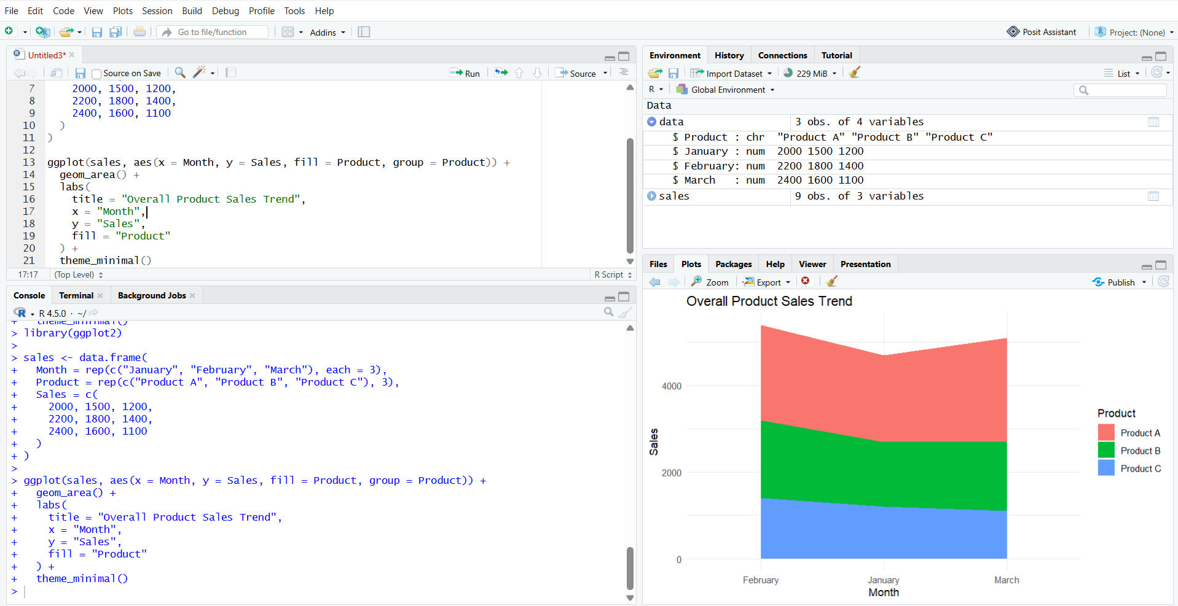
3. Table – Monthly Sales
Aim
To create and display a table showing the monthly sales data for each product.

Code:
data <- data.frame(
Product_ID = c(1, 2, 3),
Product_Name = c("Product A", "Product B", "Product C"),
January_Sales = c(2000, 1500, 1200),
February_Sales = c(2200, 1800, 1400),
March_Sales = c(2400, 1600, 1100)
)
print(data)
Output:
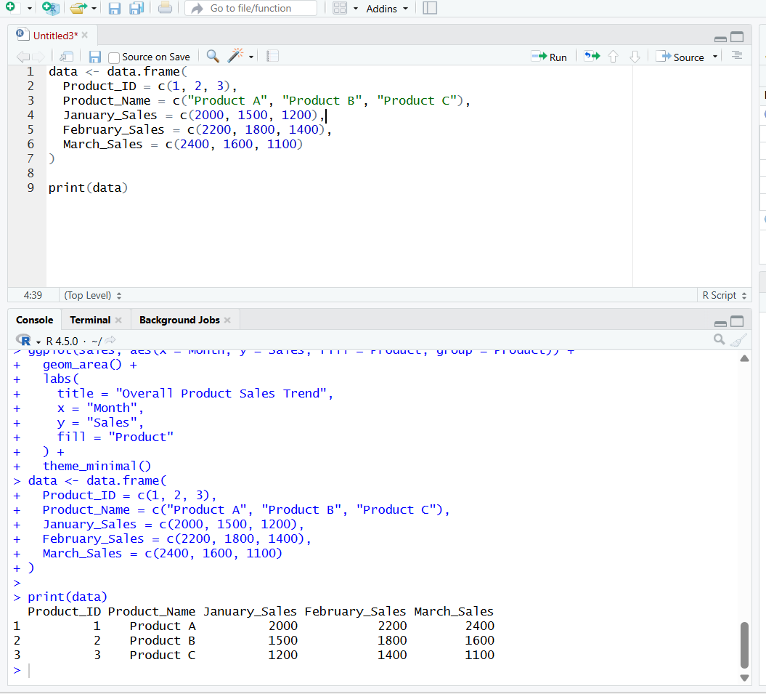
4. Dashboard
Aim
To develop an interactive dashboard combining the grouped bar chart, stacked area chart, and sales table for effective analysis of product sales.
